# **VBA Homework, Ken Ho Khek Khuan**

# VBA Code Screenshot – 2016

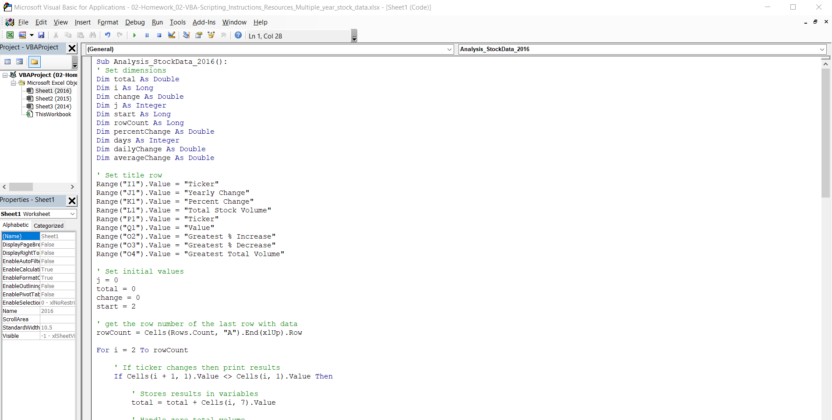

# VBA Code Screenshot – 2015

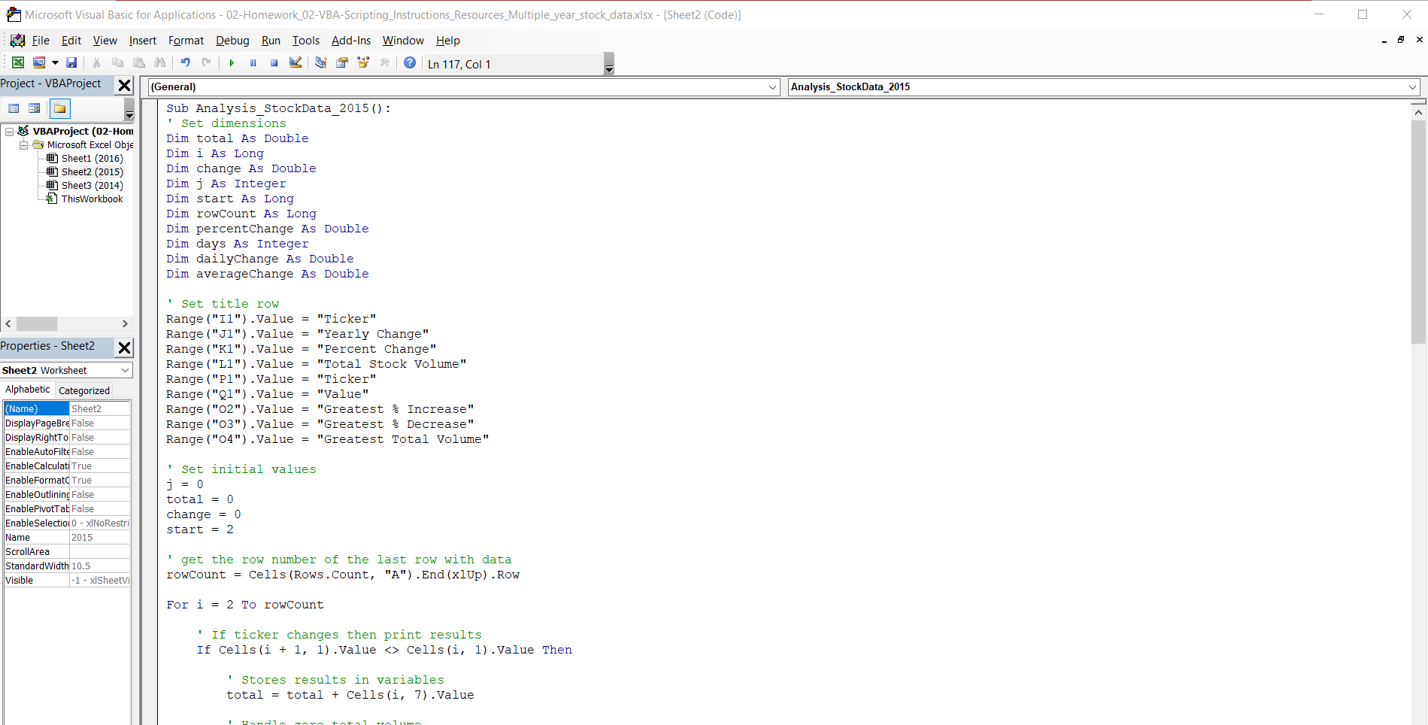

# VBA Code Screenshot – 2014

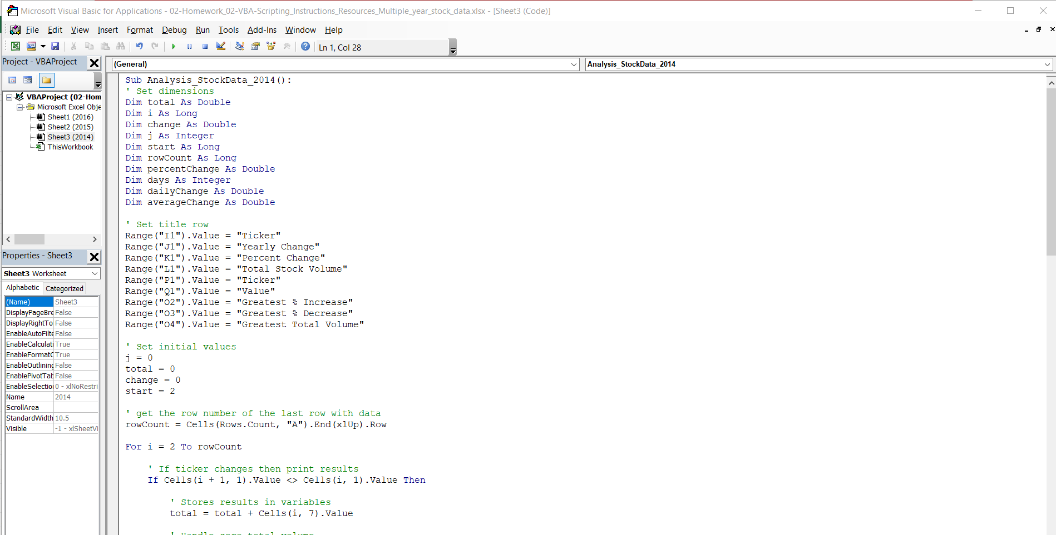

# Result Screenshot - 2016

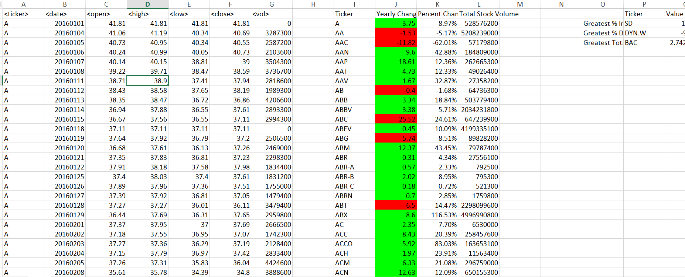

# Result Screenshot - 2015

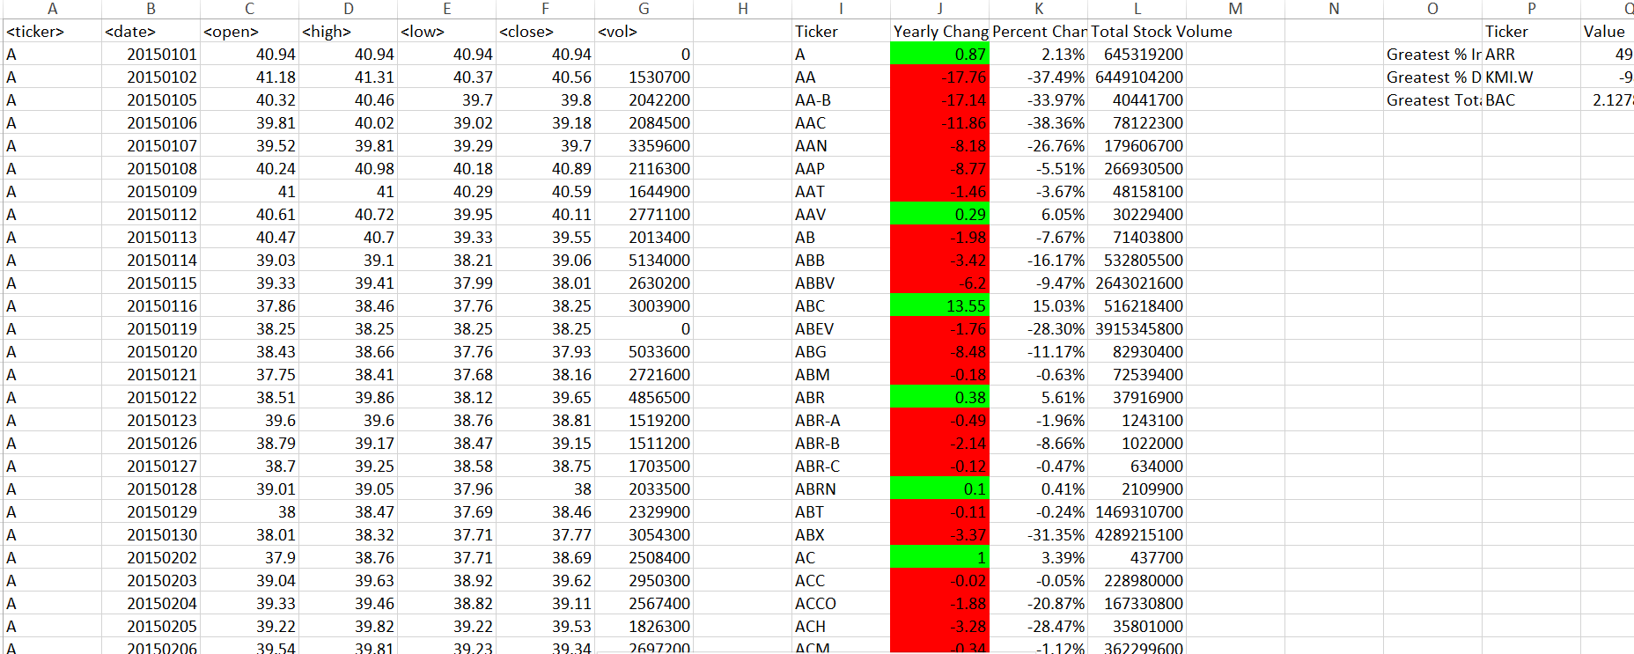

# Result Screenshot - 2014

